14. Backup and Restore (tar&gzip)

Tasks

1. Create a backup of your Music folder (or any folder with at least 3 files) using the tar command and compress it with gzip, saving the output as music_backup.tar.gz in your home directory.

ANS:

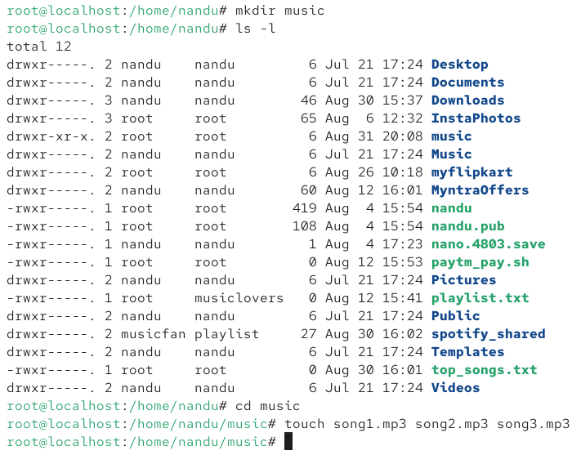

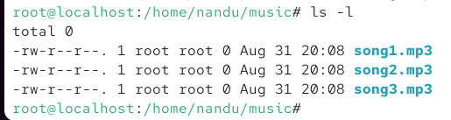

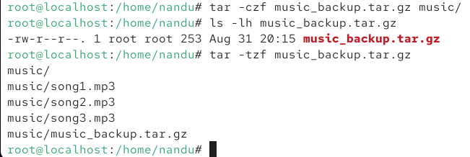

2. Extract the contents of a tar.gz file (for example, music_backup.tar.gz) into a new directory called restored_music and verify that all files are restored correctly.

ANS:

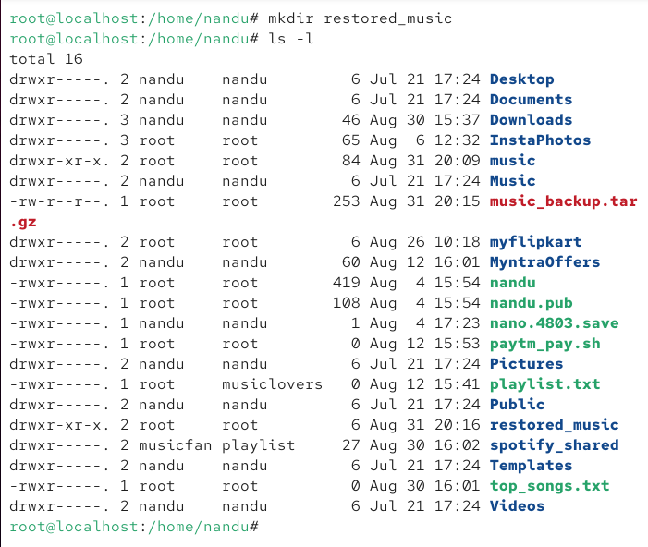

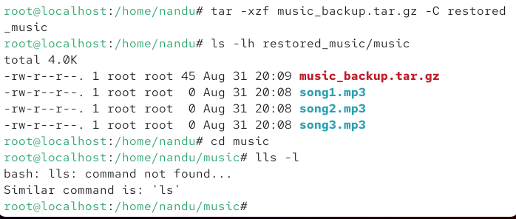

3. Write a shell command that creates a compressed backup of all .jpg images from your Downloads folder into a file named images_backup.tar.gz, excluding any files larger than 5MB.Use the find command with size filtering and tar with --files-from.

ANS:

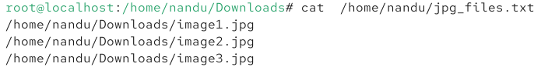

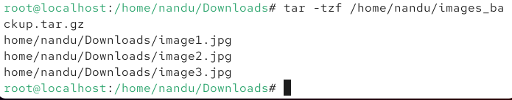

4. Simulate a restore scenario: delete one file from your original Music folder, then use your music_backup.tar.gz archive to restore only the deleted file without overwriting the rest.

ANS:

